**Lab – 21**

**Student Name: Navneet P**

**Student ID : AF0411619**

***Topic: Data Visualization***

**About Matplotlib**: Matplotlib is a powerful plotting library in Python used for creating static, animated, and interactive visualizations. Matplotlib’s primary purpose is to provide users with the tools and functionality to represent data graphically, making it easier to analyze and understand. It was originally developed by John D. Hunter in 2003 and is now maintained by a large community of developers.

**Installation**: pip install matplotlib

**Version:** import matplotlib matplotlib.__version__ =====> (3.9.2)

Functions/submodules used in this Assignment:

1. **Pyplot**: module in Matplotlib for creating static, animated, and interactive visualizations.
2. **Matplotlib.pyplot.plot():** Creates a plot line graph
3. **Matplotlib.pyplot.bar():** Creates a bar chart
4. **Matplotlib.pyplot.subplots():** Creates multiple subplots in a single figure for complex layouts.
5. **Set():** A direct way of adding labels and title in just a single function call
6. **Matplotlib.pyplot.show():** Adds a label to the x-axis of the plot.
7. **Matplotlib.pyplot.xlabel():** Adds a label to the x-axis of the plot.
8. **Matplotlib.pyplot.ylabel():**  Adds a label to the y-axis of the plot.
9. **Matplotlib.pyplot.title():** Adds a title to the plot.
10. **Grid():**  Adds grid lines to the plot for easier reading of data points.
11. **Matplotlib.pyplot.bar_label():** Adds labels to the bars in a bar chart to display values on each bar.
12. **Pandas.read_excel():** reads the path specified excel workbook

Example 1: Create a basic graph using list data and the matplotlib library.

Solution:

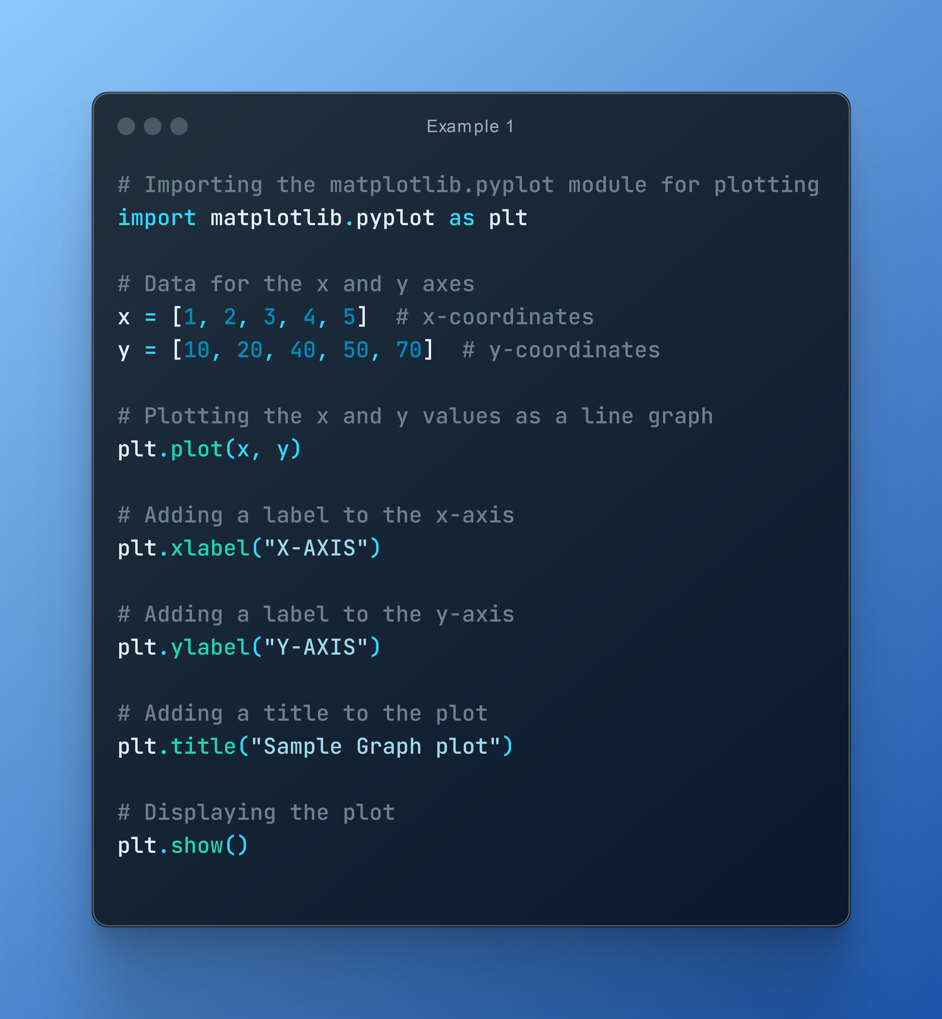

Output:

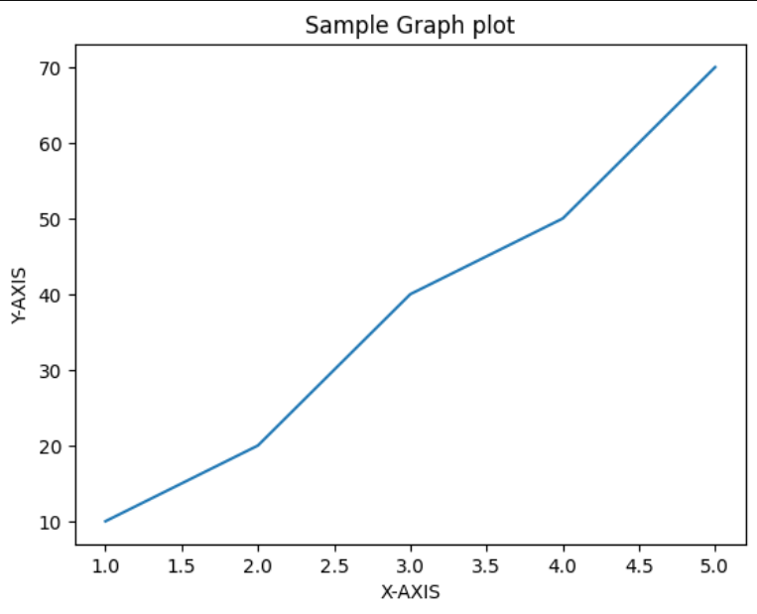

Example 2: Create a simple sine wave based graph using matplotlib.

Solution:

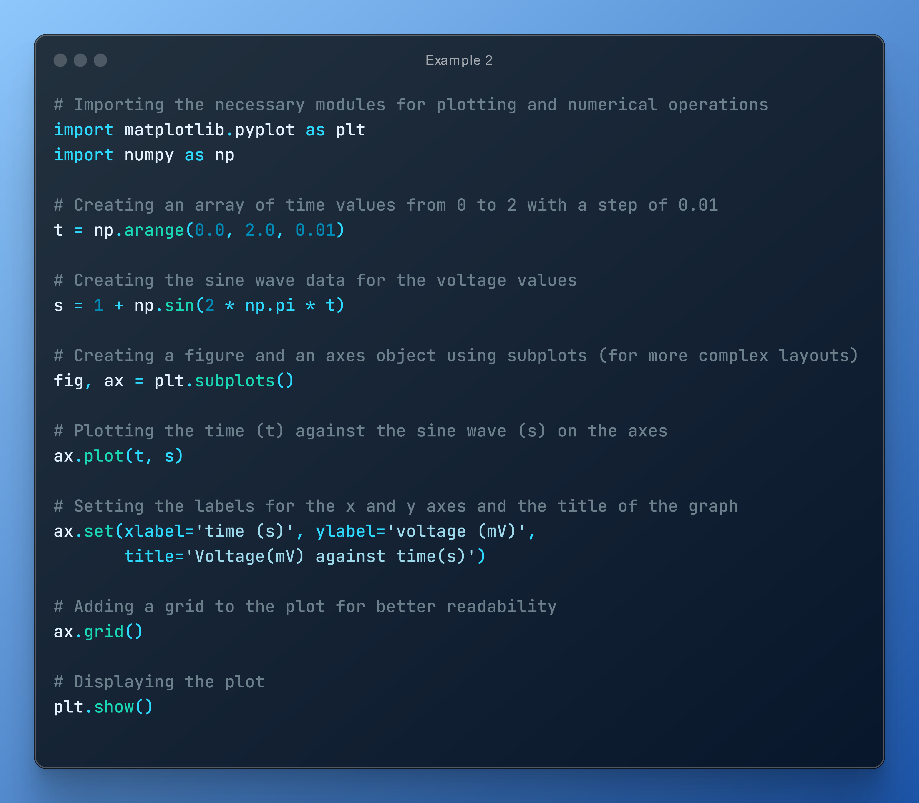

Output:

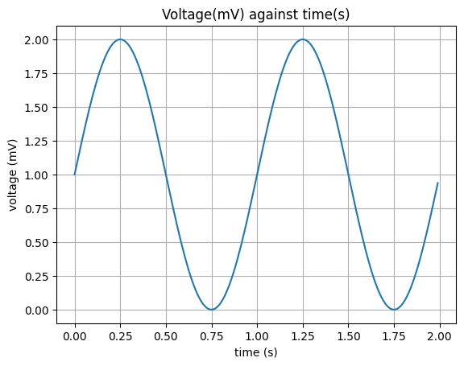

Q1. Create sample line chart using matplotlib

Solution:

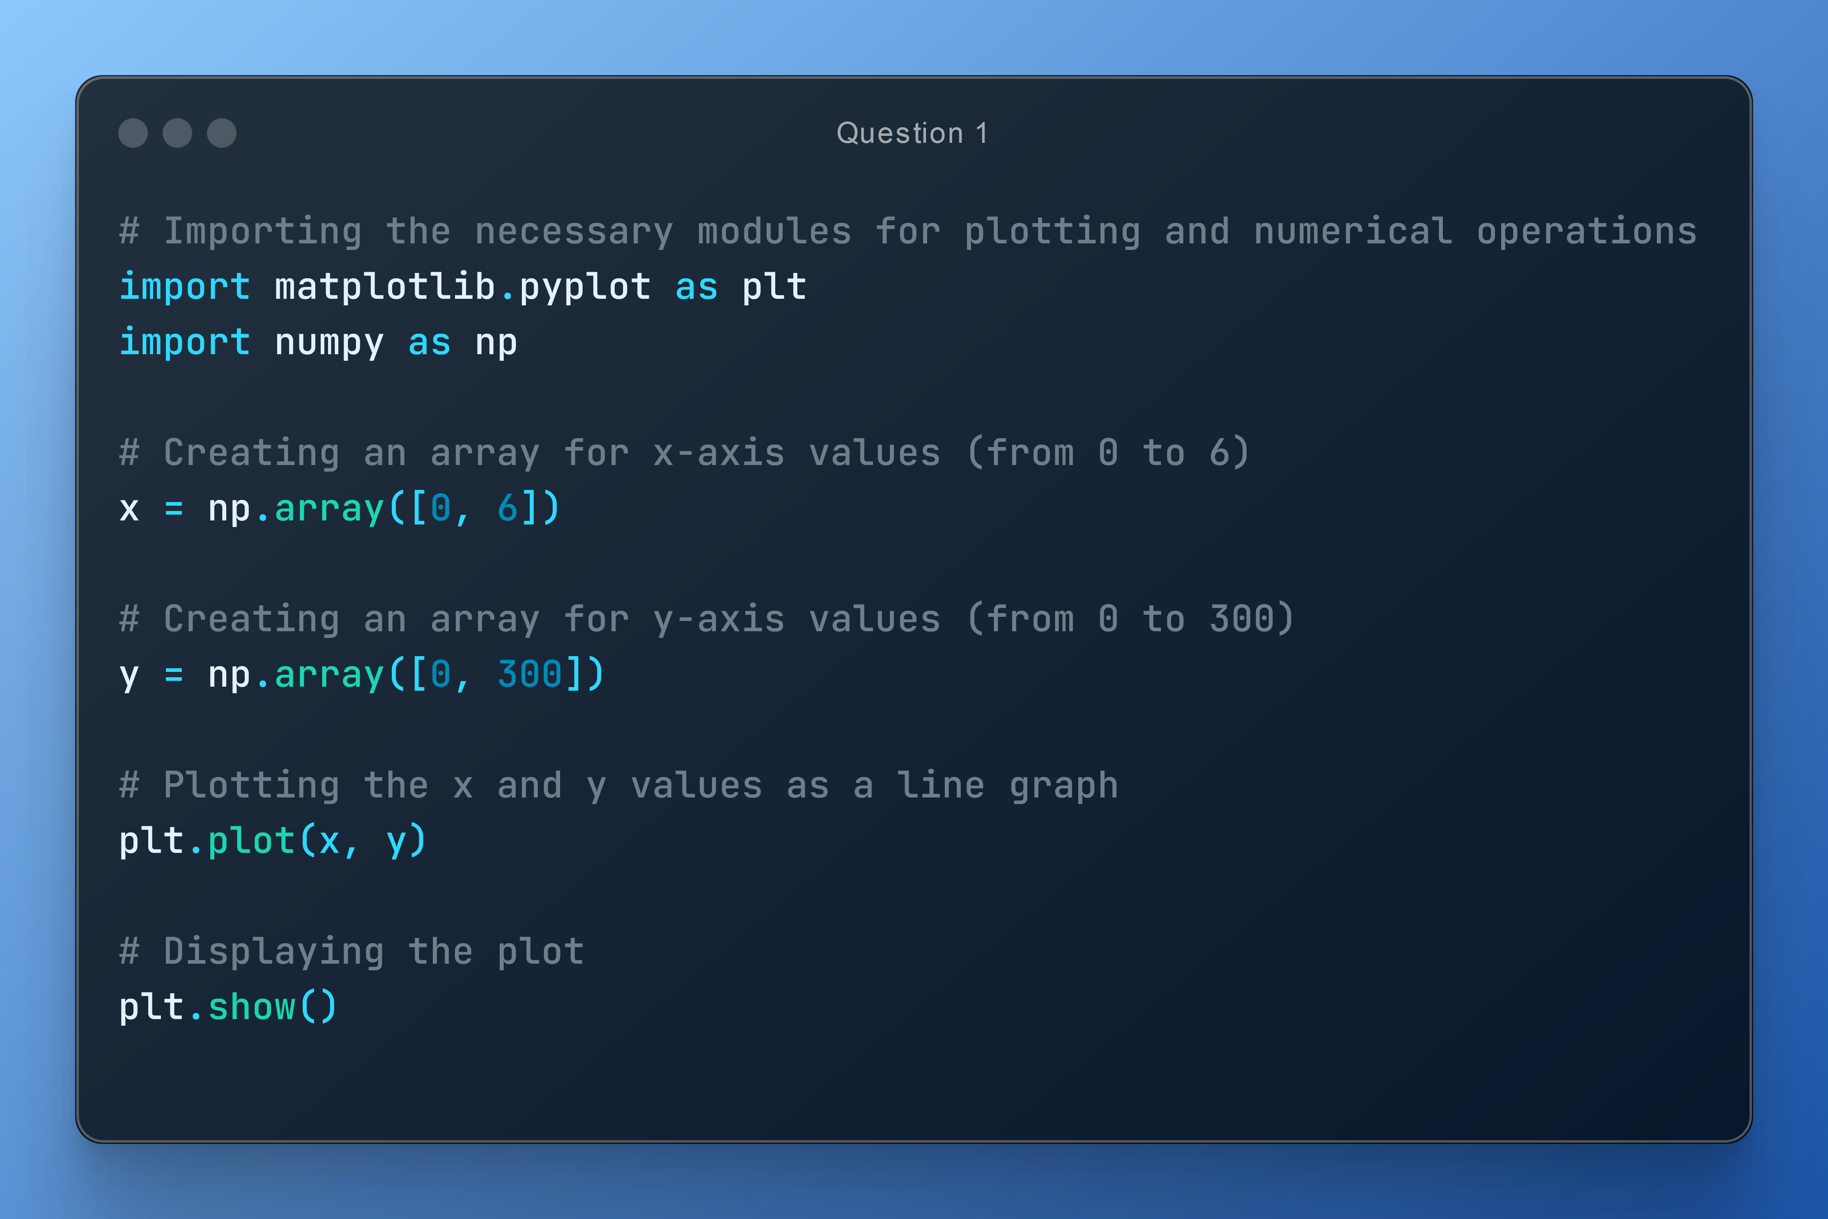

Output:

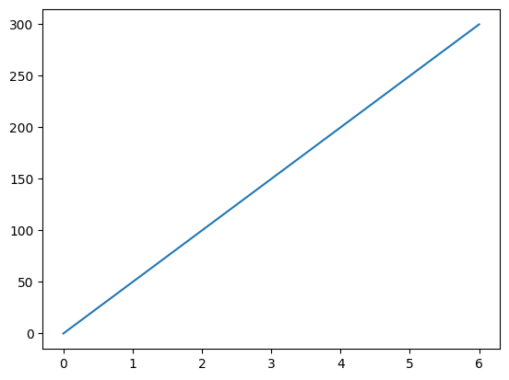

Q2. Create Bar Chart using Sample data of employee salary report with different bar colors, data labels.

Solution:

Approach would be to first create a sample dataset preferably in excel with different columns such as Empid, Empname and their salary. In this instance, we’ll be formulating a bar chart for just 5 people in the organisation for observational purposes.

Below is the dataset used for the bar chart. We’ll be using pandas library to import the raw data into the code and work with it.

Sample Dataset:

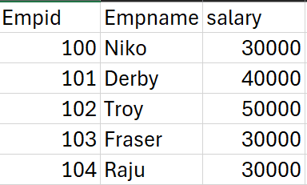

The read_excel() functions returns a dictionary with the column names as keys and the data in the form of lists as its values. We then store these lists by using their specified keys (Empid, Empname, Salary) into a numpy array and convert them into x and y values for the graph. For the actual graph we would use the matplotlib library and a bunch of its functions.

Below is the code doing the very task mentioned above:

Code:

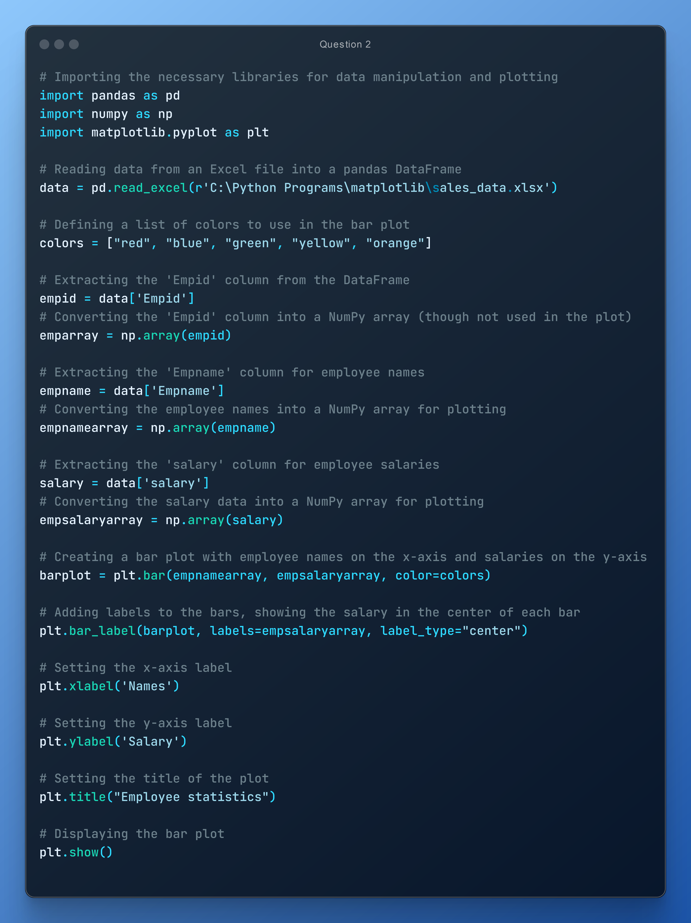

Output:

